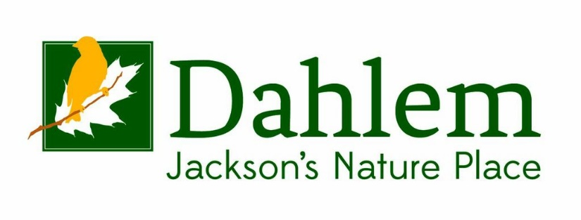

Job Description
Development Director
Employee Status: Exempt, Full Time
Date Posted: August 12, 2021
Primary Relationships
Reports to: Executive Director

Summary
The Development Director reflects the leadership qualities of the Dahlem mission and manages the development activities of the Dahlem Conservancy. The DD serves as the team leader of the Board’s Development Committee along with coordinating special events and cultivation practices from the Benevon model while integrating the vision, culture, and core values of the Dahlem Conservancy.

Job Responsibilities
- Direct the planning, recruiting and execution of the Annual Benefit Fundraiser Breakfast or Luncheon
- Recruit table captains from Discover Dahlem Tours and other resources
- Conduct Point of Entry events
- Make all arrangements for the event – site location, AV needs, menu, seating arrangements
- Direct the follow-up and cultivation of attendees according to the Benevon model at Dahlem
- Meet prospective donors and supporters on a continual basis to establish effective communications with them

- Direct the Benevon model of fundraising at Dahlem
- Direct the leadership of the overall implementation of the Benevon fundraising model at Dahlem.
- Meet prospective donors and supporters on a continual basis to establish effective communications with them
- Grow a major gifts program including identification, cultivation and solicitation of major donors
- Build the planned giving program with a focus on deferred gifts such as bequest expectancies, trusts, wills
- Direct the annual year end ask program, including mailings and annual fundraising drives
- Make public appearances/accept speaking engagements to share information about the Dahlem Center with the community.
- Oversee and keep current the Bloomerang fundraising database system that has been adopted at Dahlem
- Oversee creation of publications to support fund raising activities
- Write content for both print and the Web including the Dahlem website, blog, brochures, and newsletter.
- Monitor the company’s social media and online presence

- Assist the Executive Director in the preparation and planning of the annual Development budget

- Direct and Write Grants
- Oversee grant seeking including research, proposal writing, and reporting requirements
- Engage and lead program with the staff in composing grants for operations and programs

- Direct Capital campaigns
- The Development Director in cooperation with the ED will direct any capital campaign that Dahlem has entered into

Other Job Responsibilities
- Prepare and present regular reports as directed by the Executive Director
- Maintain current and accurate donor records using Dahlem’s business systems and software
- Meet or exceed the daily, monthly and annual agreed upon metrics and KPIs (Key Performance Indicators)

Development Director Time Breakdown
- Plan fund-raising campaigns and activities - 25%
- Manage fund-raising campaigns and activities - 25%
- Recruit and train volunteer fund-raising leadership - 10%
- Identify and cultivate prospective donors - 15%
- Stay on top of advancements and changes that are pertinent to raising money within the community, to the organization's mission and programs, and to the development profession 10%
- Forecast and evaluate the potential of fund-raising campaigns and activities - 5%
- Produce solicitation materials and train volunteer solicitors for fund-raising campaigns - 5%
- Interact with other organization staff members - 5%

Qualifications:
- Must embrace the mission of Environmental Education and providing outdoor experiences to the people of south central Michigan
- A minimum of 1 year experience in fund raising in a nonprofit organization
- Strong interpersonal skills.
- Strong verbal and written communication skills
- Must be able to work and thrive in a team orientated environment
- Proficient with Microsoft Office, Publisher and Data Base systems
- Proficient with graphic and design software such as Photoshop, Illustrator, InDesign, and Adobe Acrobat, or have access to other design software.
- Have knowledge and experience in fund raising techniques, particularly major gift fundraising.
- Possess the skills to work with and motivate staff, board members and volunteers
- Be a “self-starter” and goal driven to initiate donor visits and fundraising calls
- Be organized and exhibit “follow through” on tasks and goals.
- Display a positive attitude, show concern for people and community, demonstrate presence, self-confidence, common sense and good listening ability.
- A bachelor’s degree in Business Management, Marketing, Communications, and Social Science is required.

